**Importing a Python module**

**Part A – Importing a given module**

As your program gets longer, you may want to split it into several files or **modules** for easier maintenance and code readability.

A module can then be **imported** into other modules or into the **main** module.

Let’s see an example:

1. Suppose you have, in the directory C:\IS111\week_1, the file greet.py , which contains two functions: say_hello and say_bye.

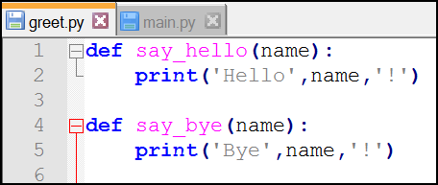

1. Suppose you have, in the same directory C:\IS111\week_1, another file called main.py, wanting to make use of the 2 functions written in greet.py.

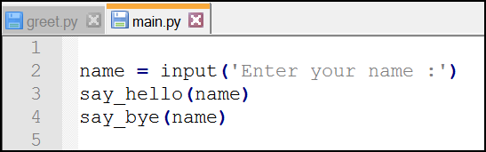

If you run the module main.py, written this way, you will get the following error:

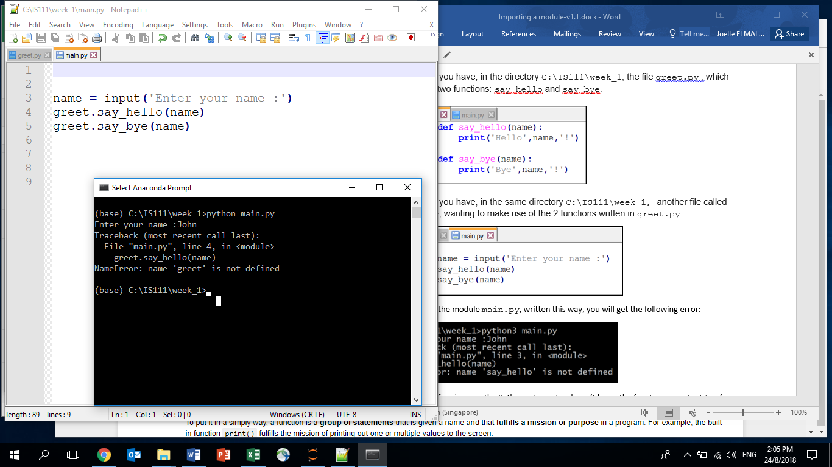

At line 3 of main.py, the Python interpreter doesn’t know the function say_hello (nor the other function say_bye).

The reason is that they have been defined in the module greet.py. Therefore we need to import the module greet into the main module.

1. The code of the main module becomes then:

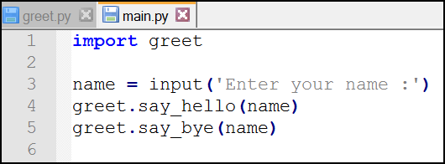

Notice here 2 things:

1. In line 1, we have the statement import greet (and NOT import greet.py)
2. When we invoke the 2 functions say_hello and say_bye, their names are preceded by “greet.“ .

Notice the **dot symbol** and the **greet** prefix: this is to express the fact that the functions are actually defined in the greet module.

When we run the code, we get the following output:

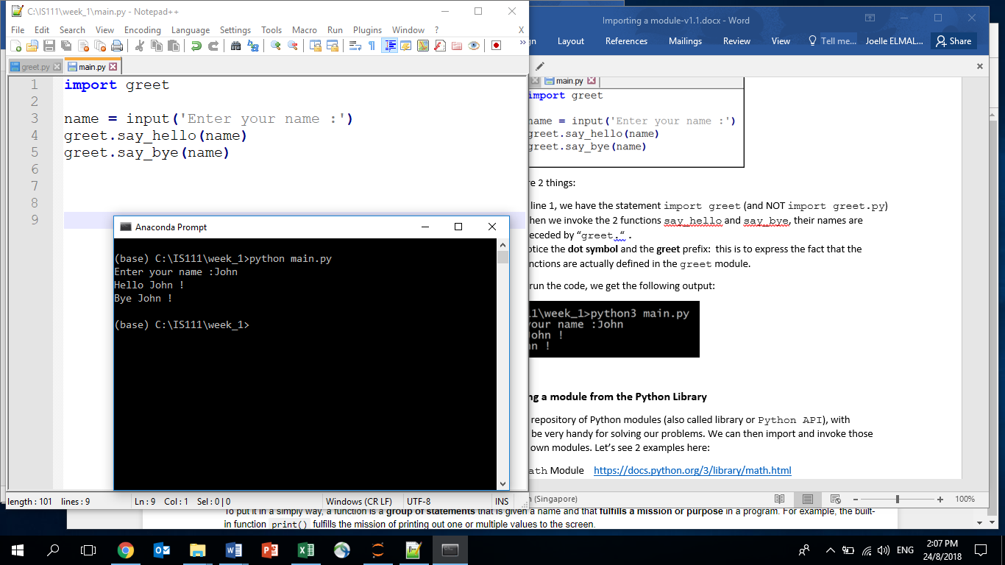

**Part B – Importing a module from the Python Library**

Python provides a repository of Python modules (also called library or Python API), with functions that can be very handy for solving our problems. We can then import and invoke those functions into our own modules. Let’s see 2 examples here:

Example 1 - The math Module <https://docs.python.org/3/library/math.html>

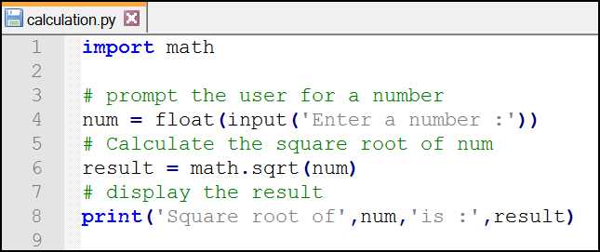

In this example, we import the math module provided by the Python library, and we invoke the square root function : sqrt(), which calculates for us the square root of the number passed in as argument to the function.

When we execute the code, we get the following output:

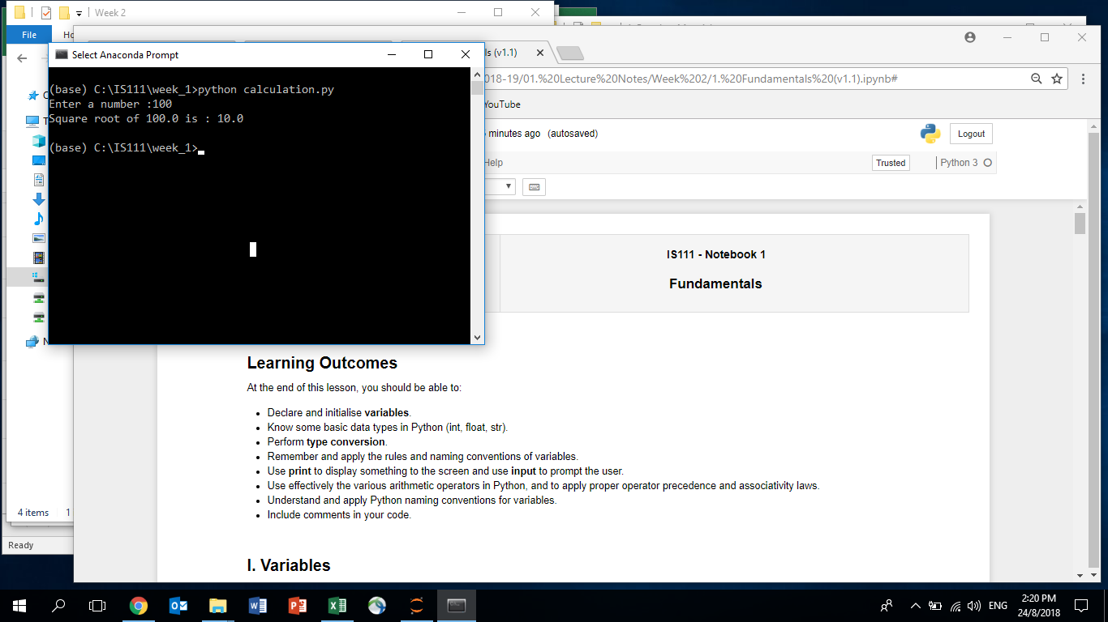

Example 2 - The random Module <https://docs.python.org/3/library/random.html>

The random module is also a useful module that allows us to generate random numbers easily as shown below:

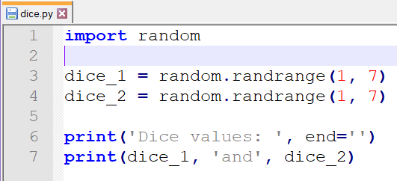

1. In line 1, we import the random module provided by the Python library
2. In Line 3 and 4, we invoke the randrange function from the random module, to generate two integer random numbers between 1 (inclusive) and 7 (exclusive). In other words, the random number generated by randrange(1, 7) can be 1, 2, 3, 4, 5 or 6.

Notice again that the function randrange needs to be preceded by “random.” (do not forget the dot!)

When we execute the code, we get the following output:

